
Cricket in the Adelaide Schools Sports Association
As with all sports played in our association, the aim, at all levels, is to encourage a healthy spirit of competition between schools, provide opportunities for maximum participation and to promote personal growth through behaviours which are, always, based on and congruent with the mutually shared values our schools promote.
Cricket is an exciting game that encourages leadership, friendship, and teamwork, which brings together people from different nationalities, cultures and religions, especially when played within the Spirit of Cricket.
The Preamble – The Spirit of Cricket
Cricket owes much of its appeal and enjoyment to the fact that it should be played not only according to the Laws, but also within the Spirit of Cricket.
The major responsibility for ensuring fair play rests with the captains, but extends to all players, umpires and, especially in our association, teachers, coaches, and parents.
Respect is central to the Spirit of Cricket:
Respect your captain, team-mates, opponents, and the authority of the umpires.
Play hard and play fair.
Accept the umpire’s decision.
Create a positive atmosphere by your own conduct and encourage others to do likewise.
Show self-discipline, even when things go against you.
Congratulate the opposition on their successes and enjoy those of your own team.
Thank the officials and your opposition at the end of the match, whatever the result.
The Competition
Scheduling
Matches may be played on synthetic or turf pitches.
Matches are played at the ground of the first named team.
Record keeping
Scoring is to be completed with PlayerHQ or entered PlayerHQ by the home school by Tuesday following each game.
Schools are responsible for adding selected players to PlayerHQ.
Law 1 – The Players
Individual schools are responsible for the selection of their teams from current students.
Award
SAAS 1st XI Cricket Awards calculated through PlayerHQ score entry.
Only the minor round performances count towards the SAAS awards
Player of the Year is confirmed through Mycricket Championship points.
Batsman of the Year and Bowler of the Year through player scores up to the minor round

Primary Cricket – Updates 2025 September
Philosophy
Coaches are expected to rotate batting and bowling order on a weekly basis so that all players feel that they are contributing to the team’s performance. The concept of two or three students dominating the batting and then bowling most overs is to be completely discouraged.
Winning matches at this level is NOT the prime reason for playing. Coaches should primarily focus on players enjoying the game and developing their skills.
Coaches are strongly encouraged to discuss the philosophy of each game with the opposing coach prior to the commencement of play.
Year 4/5 Modified Rules – Cricket Australia Stage 1
Ball – 142-gram Kookaburra Supersoft jnr. Modified ball (circumference 21-22.5cm, ideal weight 120-140g).
These are one day games - 16 overs per team.
Games scheduled for Friday afternoon – playing hours: 4.00 p.m. to 6.00 p.m.
If travel allows, games can begin earlier by mutual agreement.
Coaches/Managers can modify the length of the game to suit the two (2) hour time limit
Pitch – 16 Metres (outfield or hard wicket surface)
Field – 40 Metres maximum measured from the batter’s stumps end
Team Numbers – 8 players per team on the field at any one time (players can be rotated or numbers can be negotiated with the opposition team).
A Drinks break may be taken at the ten (8) over mark of each innings.
Batting
Bat size: Size 4 (<1.8lb or <800gm) is recommended.
Unlimited dismissals for the batsman – coaches divide the innings allocation of 120 balls (20 overs) by the number of players to ensure that players have an equal opportunity to bat.
No Balls and Wide’s count towards the ball count and are not rebowled.
The following dismissals apply in this format: Bowled, Caught, Caught and Bowled, Run Out, Stumped, Hit Wicket.
Batsmen swap ends after a dismissal (If a run out, then the not out batsman faces the next ball).
As there is allowances for varying team size, the following retirement rules apply:
- 8 player team – batters retire at 12 balls
- 9 player team – batters retire at 13 balls
If there is an extra ball to be bowled, the batter facing at the time will face the extra ball (i.e., 17 x 7 = 119)
Batters are to retire as soon as they face their allotted balls, not at the end of the over.

Bowling
Six (6) balls maximum per over (regardless of No Balls and Wide’s).
Maximum of four (4) overs per bowler.
All overs are bowled from the same end for the entire game.
All players are to bowl (each Wicketkeeper is to bowl one over each).
Number of bowlers per bowling option
- 8 player team (6 x 2 overs, 2 x 1 over)
Bowling breakdown based on maximum four (4) overs per bowler. It is recommended coaches employ a rotation policy to ensure all players get the opportunity to bowl maximum overs throughout the season.
Fielding
No fielders within 15 metres of the bat (except the wicketkeeper).
All fielding positions (including the wicketkeeper) are to be rotated during the innings to ensure maximum player engagement and opportunity to have experience in a variety of positions.
Each team is required to use two (2) wicket keepers (8 overs each).
If more than 8 players are present at a match, they should rotate onto the field each over.

Protective Equipment
Helmets must always be worn whilst batting and wicket-keeping.
Pads, gloves, protector.
Additional safety equipment can be worn based on match conditions and/or personal preference.

. 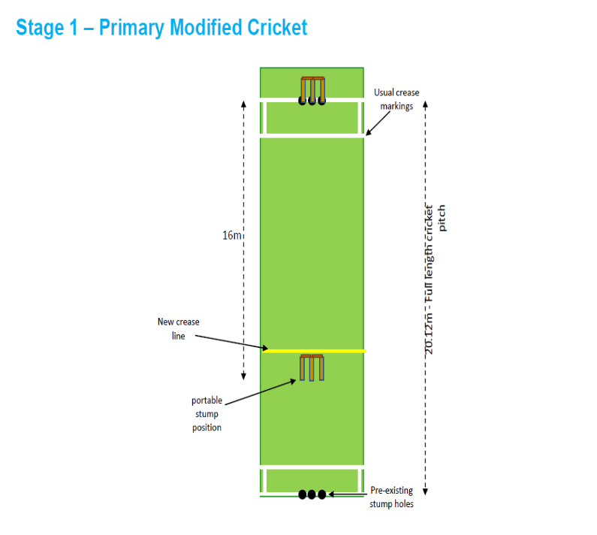 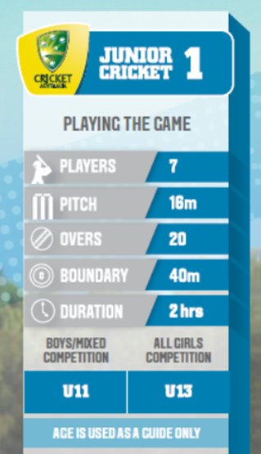

Tips for Managers/Coaches - Ways to keep your game moving and finishing on time
- Complete your team sheet the night before the game.
- Set up team marquees close to the boundary.
- Make sure the scorers are sitting under shade and close to the boundary to assist with player names and advising ball counts.
- Involve parent volunteers to assist with marking boundaries, crease lines and shade shelters, leaving the coach to work with their team running warm-ups etc.
- Add a chalk line to mark ‘centre’ at the striker’s end as a reference point for batters, this means batters won’t need to continually mark centre.
- Have all upcoming batters padded up and ready to go. The next batter in should have helmet and gloves on.
- Rotate fielders with the next bowler fielding nearest to the bowler’s end.
- Encourage fielders to jog between positions ready for the next over.
- When rotating extra players onto the field, swap them with the bowler who just finished their over.
- Swap wicketkeepers during a drinks break.
- Where possible, if there is an extra player, have them padded up and ready to go to replace the outgoing wicketkeeper.
- Place team drinks and water bottles together in a carry tray near the boundary.
- The central umpire is the critical driver of the game, the time it is played in and the spirit in which it is played.

Year 5 / 6 Cricket (U/11-U/12) Cricket Australia Stage 2
Ball – 142-gram Kookaburra Practice or Tuff Pitch
One day games – each team bats for 20 overs
Pitch – 18 Metres (Stumps at the popping crease)
Field – 45 Metres maximum
Team Numbers – 9 players per team on the field (players can be rotated or numbers can be negotiated with the opposition team)

Batting
Bat size: Size 5 or 6 (weight <2lb or <900g) is recommended.
Players retire after facing 13 balls.
All balls (regardless of whether wides/no balls) will be included in the batter’s ball count.
A warning given for LBW.
At the discretion of coaches, players can be retired prior to the retirement limits
Any retired batters can return when all others have batted, in the order they retired.
If the team has more than 9 players, those players that did not bowl must bat.
The innings are deemed as closed after 8 wickets have fallen or the batting team has completed their allotted overs.

Bowling
Bowlers can bowl from one end for 5 overs.
6 balls per over – wides to not be rebowled
Maximum of 4 overs per bowler.
Number of bowlers per bowling option (to ensure maximum participation)
- 7 player team (4 x 4 overs, 3 x 3 overs)
- 8 player team (4 x 4 overs, 1 x 3 overs, 3 x 2 overs)
*Last 2 overs at the discretion of the coach
If the team has 9 players or less, all players must bowl (excluding wicketkeeper).
If the team has more than 9 players, a maximum of 9 players can bowl only. Those players that did not bat must bowl.
Coaches are encouraged to rotate the opportunity for players to bowl 4 overs in a match.

Fielding
No fielders within 10 metres of the bat (except regulation offside slips, gully and wicketkeeper)
At the discretion of the coach, all fielding positions can be rotated to ensure players can experience all positions.
If more than 9 players are present at a match, they should rotate onto the field each over.
Teams have the option to change wicketkeepers after 10 overs.

Protective Equipment
Helmets must be always worn whilst batting and wicket-keeping.
Pads, gloves, protector.
Additional safety equipment can be worn based on match conditions and/or personal preference.

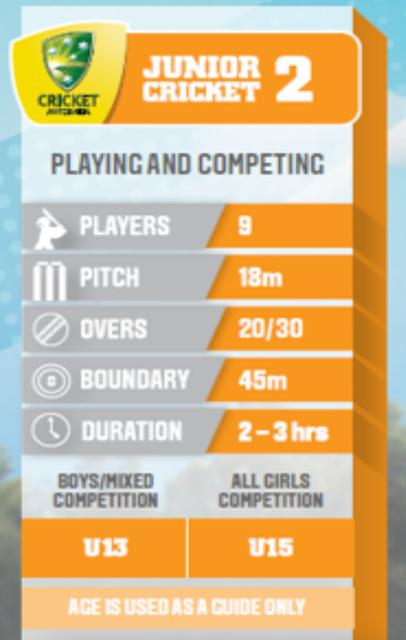

Tips for Managers/Coaches - Ways to keep your game moving and finishing on time
- Complete your team sheet the night before the game.
- Set up team marquees close to the boundary.
- Make sure the scorers are sitting under shade and close to the boundary to assist with player names and advising ball counts.
- Involve parent volunteers to assist with marking boundaries, crease lines and shade shelters, leaving the coach to work with their team running warm-ups etc.
- Add a chalk line to mark ‘centre’ at the striker’s end as a reference point for batters, this means batters won’t need to continually mark centre.
- Have all upcoming batters padded up and ready to go. The next batter should have helmet and gloves on.
- Rotate fielders with the next bowler fielding nearest to the bowler’s end.
- Encourage fielders to jog between positions ready for the next over.
- When rotating extra players onto the field, swap them with the bowler who just finished their over.
- Swap wicketkeepers during a drink break.
- Where possible, if there is an extra player, have them padded up and ready to go to replace the outgoing wicketkeeper.
- Place team drinks and water bottles together in a carry tray near the boundary.
- The central umpire is the critical driver of the game, the time it is played in and the spirit in which it is played.

