
SAAS CROSS COUNTRY 2026
PERSONAL BEST SERIES DETAILS AND MAP
Following completion of the SAAS CROSS COUNTRY SHIELD SERIES in Term 2, we move on to the PERSONAL BEST SERIES early in Term 3.

PERSONAL BEST SERIES RACE 1 – Wednesday 29 July (Week 2 Term 3) – host: Immanuel
GUESS YOUR OWN TIME / PINK ROUND
4:20 pm – race briefing for team managers (note each school must have a team manager in attendance who is able to record data for this race)
4:25 pm – race briefing for runners
4:30 pm – Middle and Senior runners run one 2 km loop – they are permitted to wear watches to note their time
After their first loop Middle and Senior runners predict the time, they will run on their second loop – then must remove all watches. Team managers are responsible for recording time predictions and enforcing watch removal!
4:40 pm – Primary runners run one 2 km loop
After the loop team managers are responsible for nominating one boy and one girl (selected according to their own random process) to be eligible for a random draw prize. The names of the runners must be provided to the recording desk by 5 pm
4:45 pm – Middle and Senior runners run their second loop
After the second loop team managers are responsible for recording times for runners and identifying the Middle and Senior runner who has run closest to their predicted time. The names of the runners, their predicted and actual time, and how close they were must be provided to the recording desk by 5 pm
5:05 pm – Presentations!
Random draw prizes – Primary girls and Primary boys
GUESS YOUR OWN TIME / PINK ROUND medal winners


PERSONAL BEST SERIES RACE 2 – Wednesday 5 August (Week 3 Term 3) – host: SPSC
SAAS INDIVIDUAL RACE CHAMPIONSHIP
4:20 pm – race briefing for team managers and runners
4:30 pm – Specific wave starts to be advised on the day.
Primary runners to race over 2 km (1 loop)
Middle Runners to race over 4 km (2 loops)
Senior Girls to race over 4 km (2 loops)
Senior Boys to race over 6 km (3 loops)

Podium finishers in each race category will be presented with medals soon after the completion of their race.

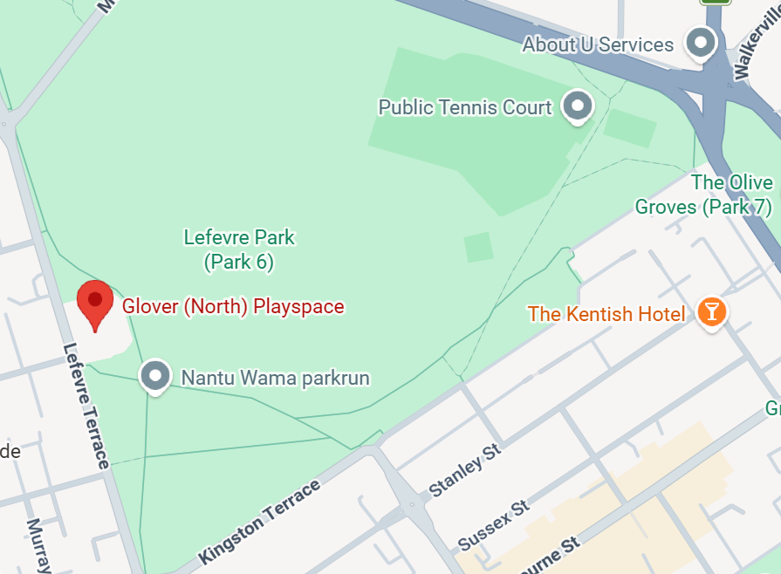
Both races will start / finish adjacent to the Glover (North) Playspace in Lefevre Park (Park 6, North Parklands). There is lots of parking available along Kingston Terrace.
START / FINISH

